***ICT LAB ASSIGNMENT 02***

***(SECTION 3: CISCO Packet Tracer)***

***NAME: YASH RAJ***

***ROLL NUMBER: 24K-0737***

1. ***Create the network topology:***

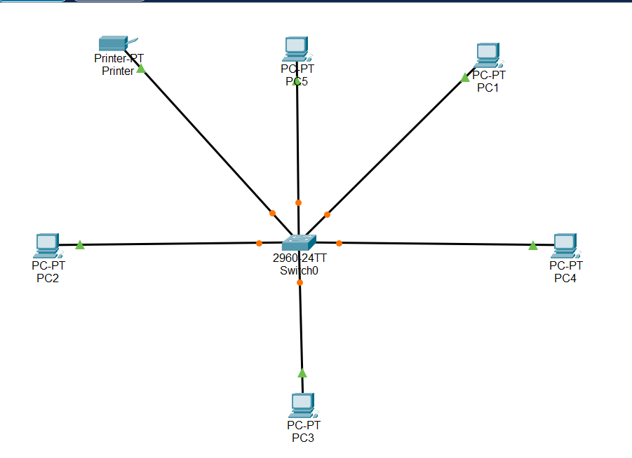

1. ***Assign IP Address:***

***Pc1:-***

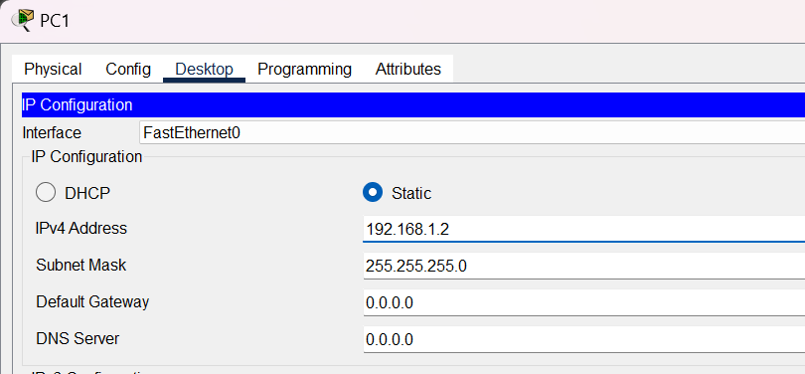

***Pc2:-***

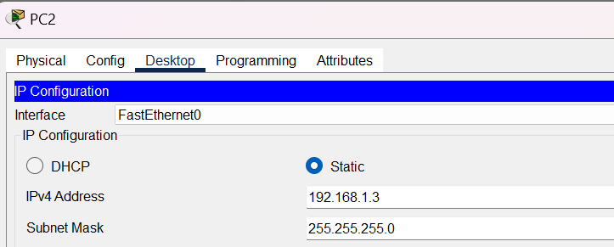

***Pc3:-***

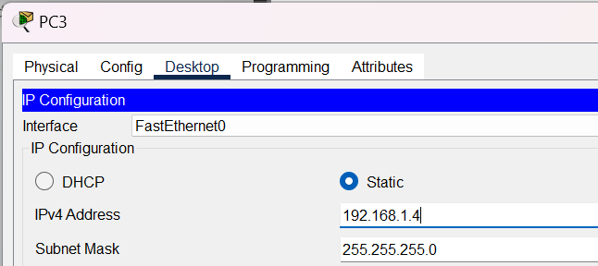

***Pc4:-***

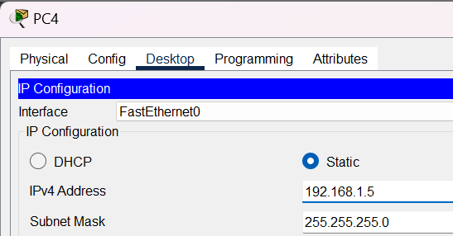

***Pc5:-***

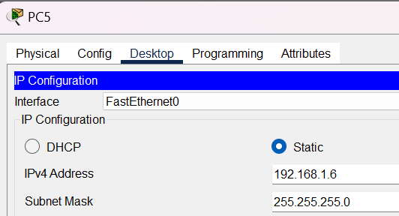

***Printer:-***

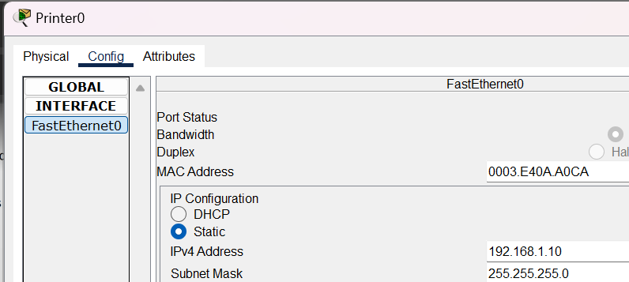

1. ***Configure Network Devices:***

***Pc1:-***

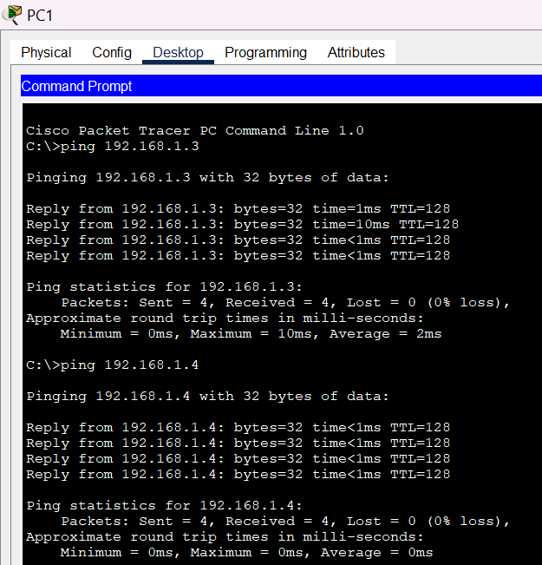

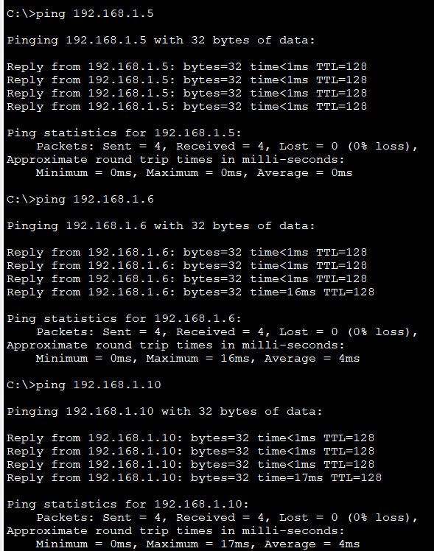

***Pc2:-***

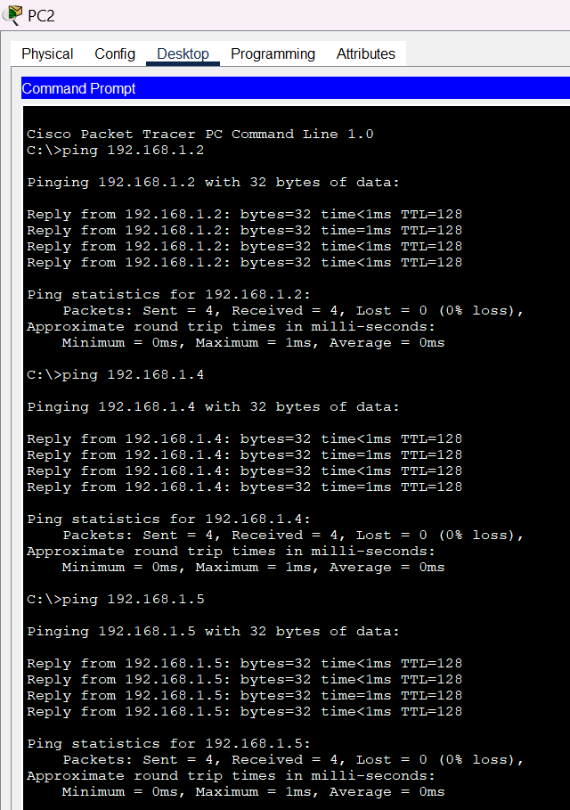

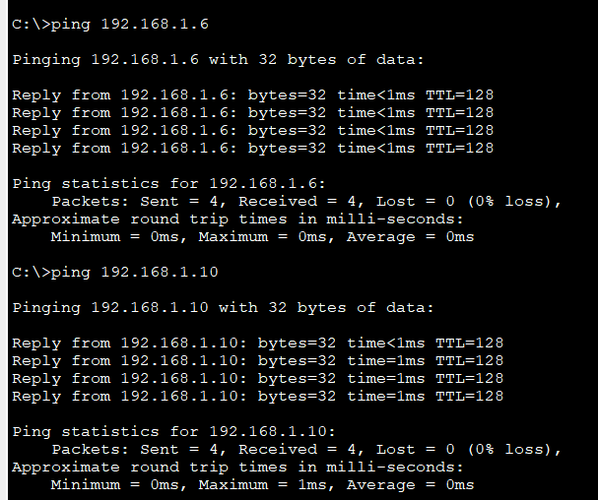

***Pc3:-***

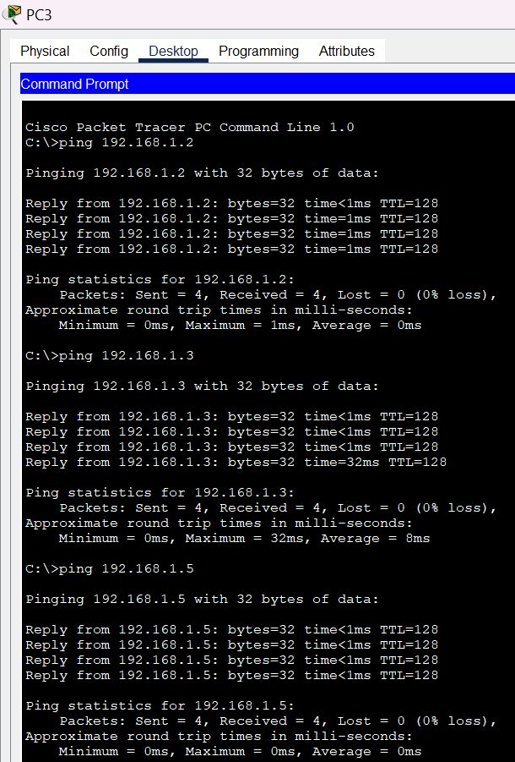

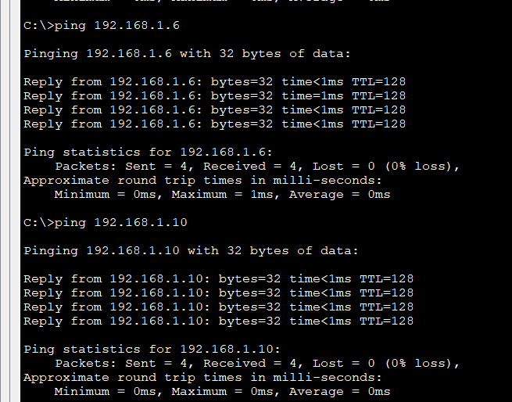

***Pc4:-***

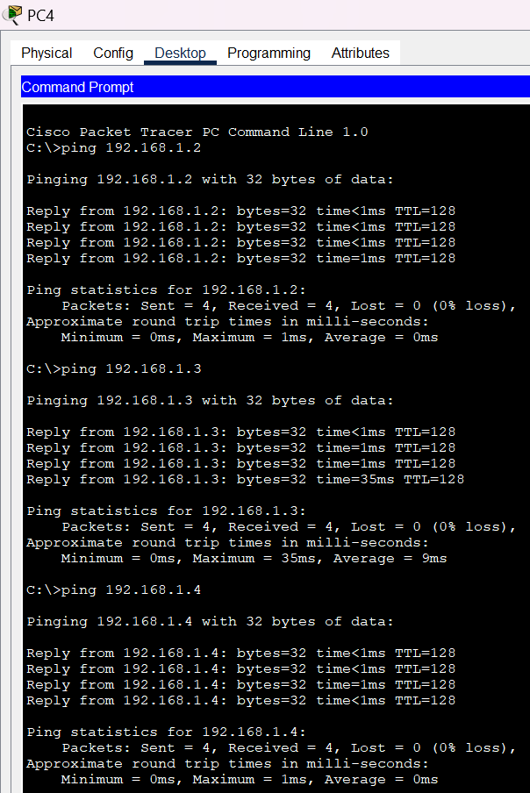

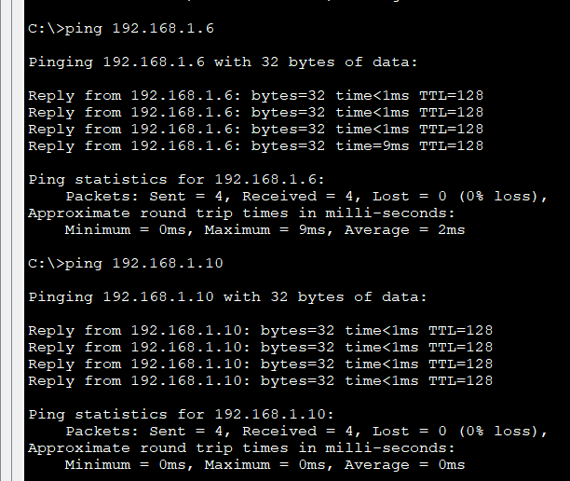

***Pc5:-***

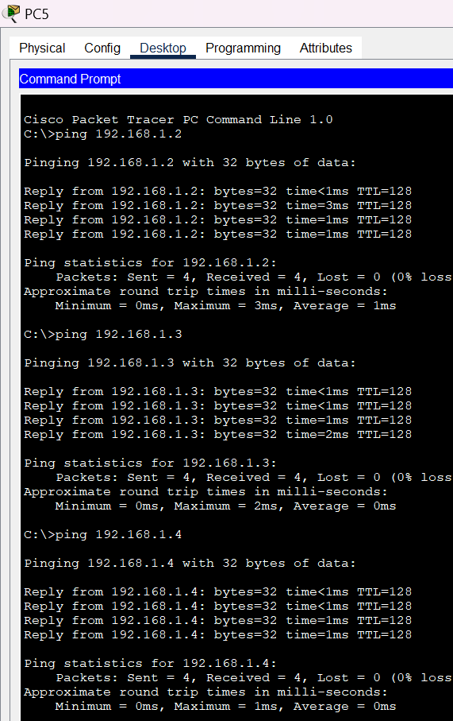

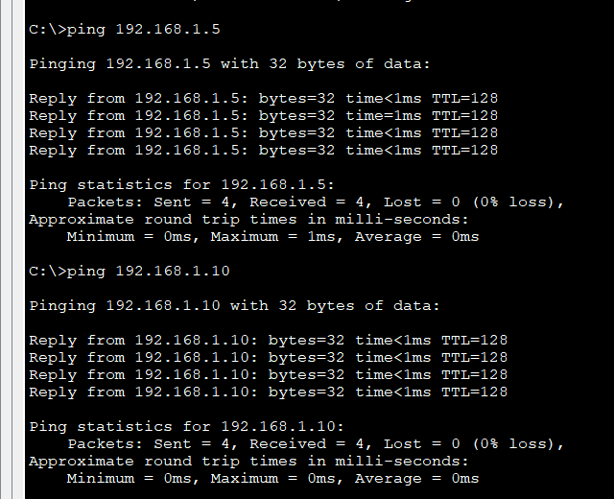

1. ***Setup Printer Sharing:***

***In progress printer sharing:-***

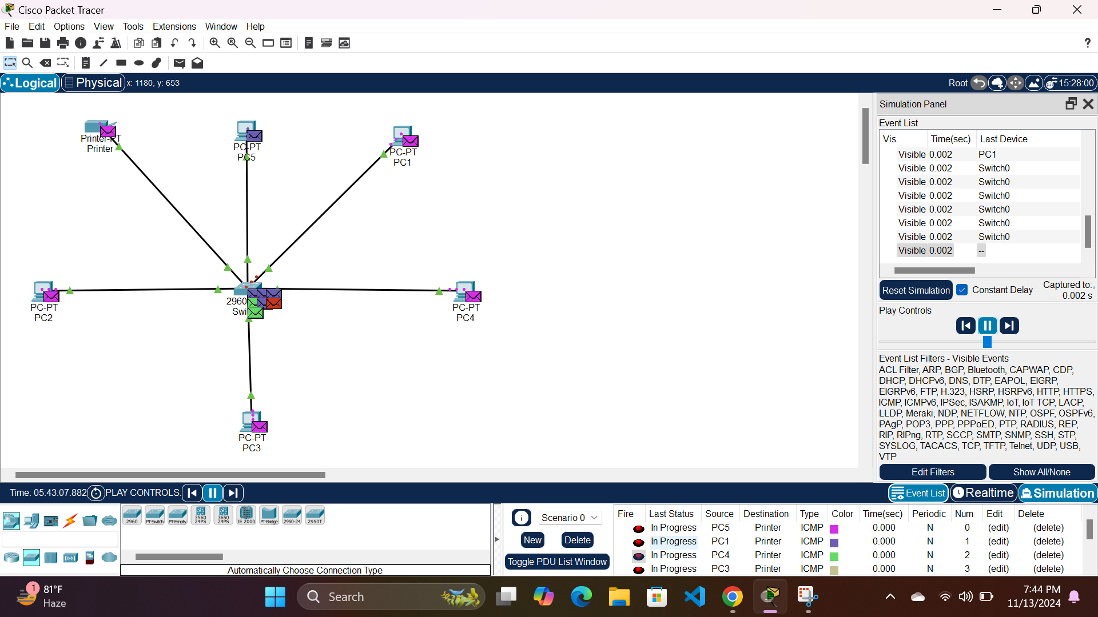

***Successful printer sharing:-***

